CORI PROJECT

BPSK MODULATION

DONE BY:

AAKANSHA MISHRA : PES1201700422

HARSHITA R VASTRAD : PES1201701717

INTRODUCTION

Today communication enters our daily lives in so many ways. The purpose of a communication system is to convey any message from an information source in an understandable form to a source destination, with the information source and the destination source be a distant apart from each other physically. To achieve this transmission of data, the data is modulated and demodulated. Modulation is the process of varying some parameter of a periodic waveform in order to use that signal to convey a message. Normally a high-frequency sinusoidal waveform is used as carrier signal.

Modulation techniques can be analog or digital.

BPSK is a digital modulation technique which has its basic concept on PSK (phase shift keying). In phase shift keying, the carrier is changed is changed according to the modulating waveform which is usually a digital signal.

In binary phase shit keying (BPSK) the transmitted signal is a sinusoid of fixed amplitude. It has one fixed phase when the data is at one level and when the data is at the other level the phase is different by

180o.

In this project we have analyzed the BPSK modulation technique. The parameters like bit rate of input data, select format(NRZ-L/ NRZ-S) , sub carrier frequency have been used for analysis.

We analyzed the techniques by using modeling and simulating various models by using MATLAB software.

SELECT BITRATE . 4K/8K/16K/32K/64K

INPUT DATA

Select Format

NRZ L/ NRZ S

DATA FORMAT

BPSK

MODULATION

Select sub carrier frequency

32K/128K/256K/512K

1 to 4 Vpp

VOLTAGE LEVELS

**Binary Phase Shift Keying (BPSK)**

***Binary Phase Shift Keying (BPSK)*** is a two phase modulation scheme, where the 0’s and 1’s in a binary message are represented by two different phase states in the carrier signal: θ=0∘ for binary 1 and θ=180∘, for binary 0.

In BPSK, only one sinusoid is taken as the basis function. Modulation is achieved by varying the phase of the sinusoid depending on the message bits. Therefore, within a bit duration Tb, the two different phase states of the carrier signal are represented as  
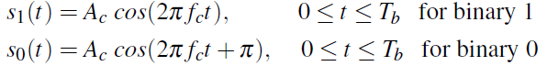

where, Ac is the amplitude of the sinusoidal signal, fc is the carrier frequency (Hz), t being the instantaneous time in seconds, Tb is the bit period in seconds. The signal s0(t) stands for the carrier signal when information bit ak=0 was transmitted and the signal s1(t) denotes the carrier signal when information bit ak=1 was transmitted.

GENERATION OF BPSK SIGNAL

Bipolar NRZ signal

BPSK signal

Binary data sequence

Bipolar NRZ level encoder

A Balanced Modulator

Carrier signal

BIT RATE

The **bit rate** is the number of bits transmitted per second. In this project, we have made the schematic(circuit) diagram which allows us to change the bitrate of the output wave. The different bitrates that we have given is:

4K, 8K, 16K, 32K and 64K. The schematic for changing the bitrate was made in simulink with the help of multiport switches and counters.

The ouputs observed for different bitrates are as follows:

4K bits/sec

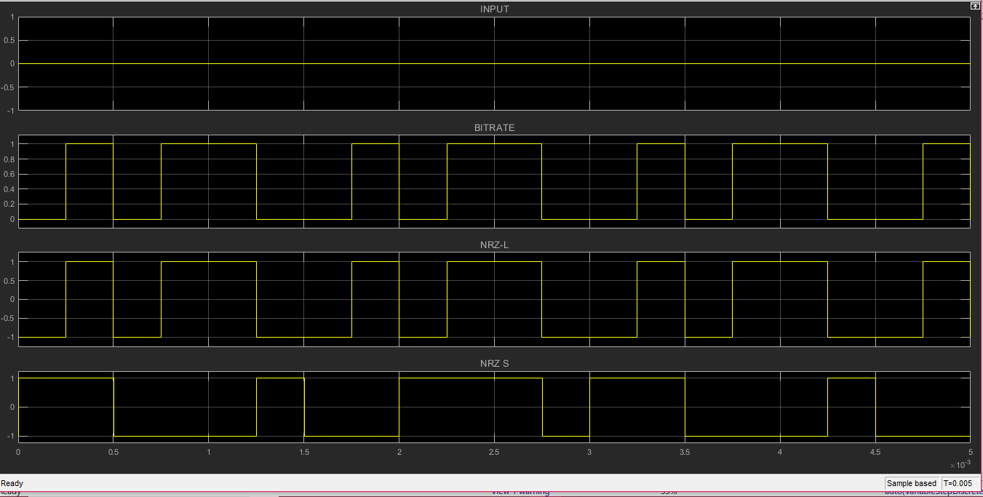

16K bits/ sec

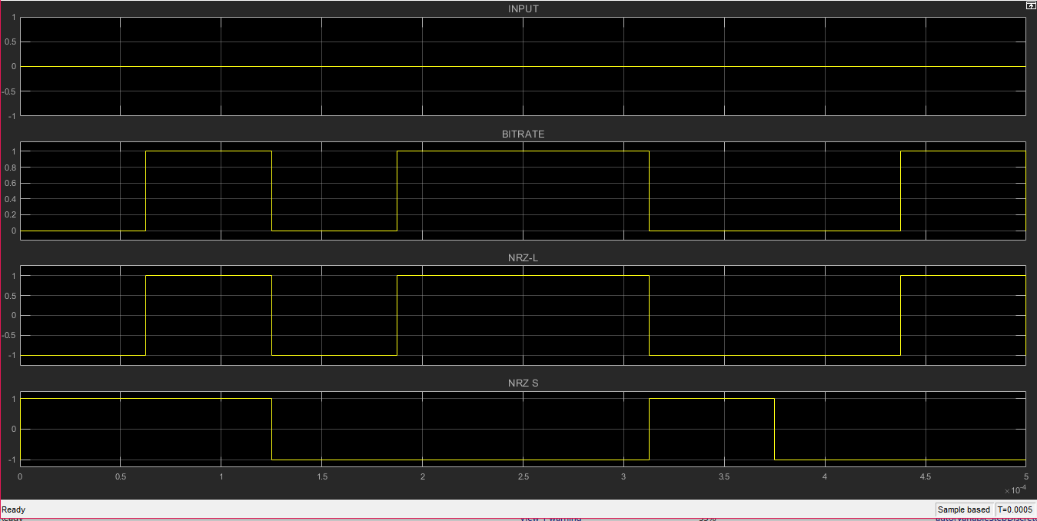

32K bits/sec

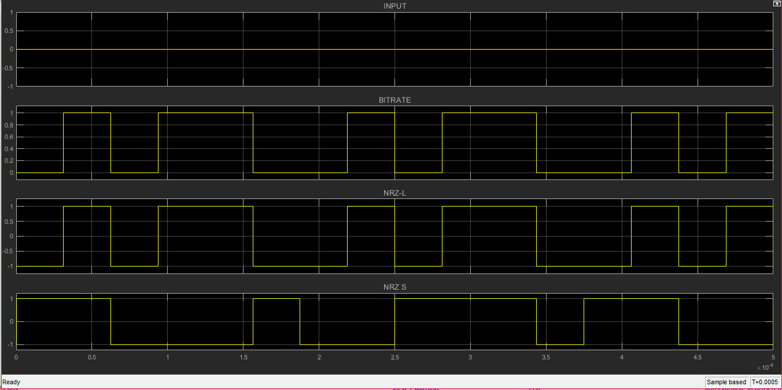

64K bits/sec

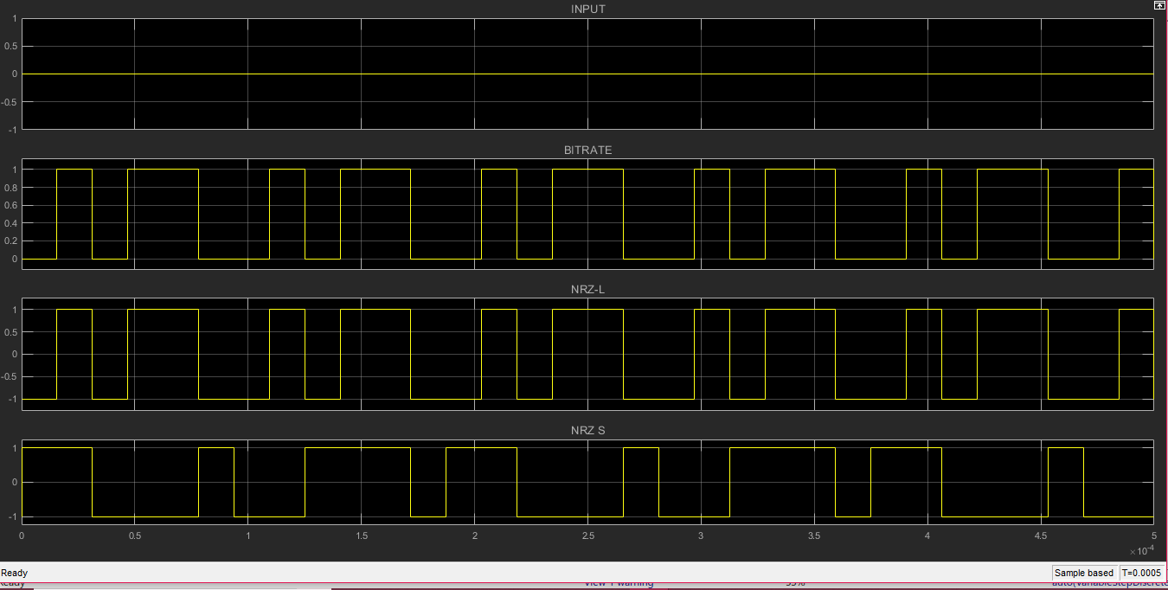The function table for bit rate is:

|  |  |
| --- | --- |
| BIT RATE |  |
| 4K | 8 bits/ 0.002s |
| 8K | 8 bits/ 0.001s |
| 16K | 8 bits/ 0.0005s |
| 32K | 8 bits/ 0.00025s |
| 64K | 8 bits/ 0.000125s |

DATA FORMAT

in this project, we have used two types of data select formats, NRZ-L AND NRZ-S

In [telecommunication](https://en.wikipedia.org/wiki/Telecommunication) a **non-return-to-zero** level (**NRZ-L**) [line code](https://en.wikipedia.org/wiki/Line_code) is a [binary](https://en.wikipedia.org/wiki/Binary_coding) code in which ones are represented by one [significant condition](https://en.wikipedia.org/wiki/Significant_condition), usually a positive voltage, while zeros are represented by some other significant condition, usually a negative voltage, with no other neutral or rest condition

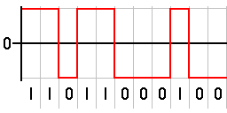

NRZ-S is binary encoding scheme in which a signal parameter, such as electric current or voltage, undergoes a change in a significant condition or level every time that a "zero" occurs, but when a "one" occurs, it remains the same, *i.e.*, no transition occurs.

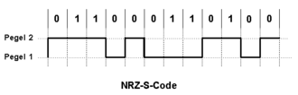

MODULATION

In electronics and telecommunications, **modulation** is the process of varying one or more properties of a periodic waveform, called the carrier signal, with a **modulating** signal that typically contains information to be transmitted.

SUB CARRIER FREQUENCIES

In this part of the project, we varied the frequencies of the input sine wave, which acts as the carrier in the modulation. The various varied frequencies were:

32K, 128K, 256K, 512K

The waveforms for the different sub carrier frequencies are:

32K Hz

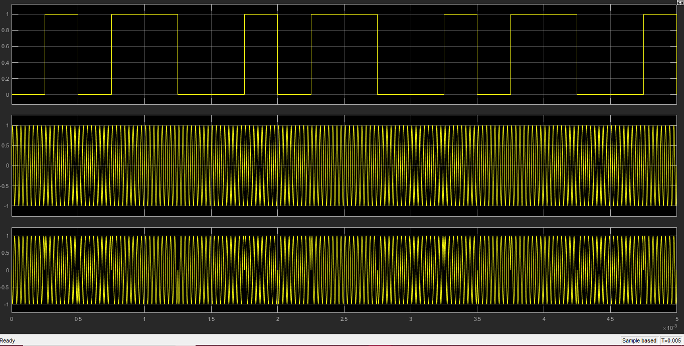

128 K Hz

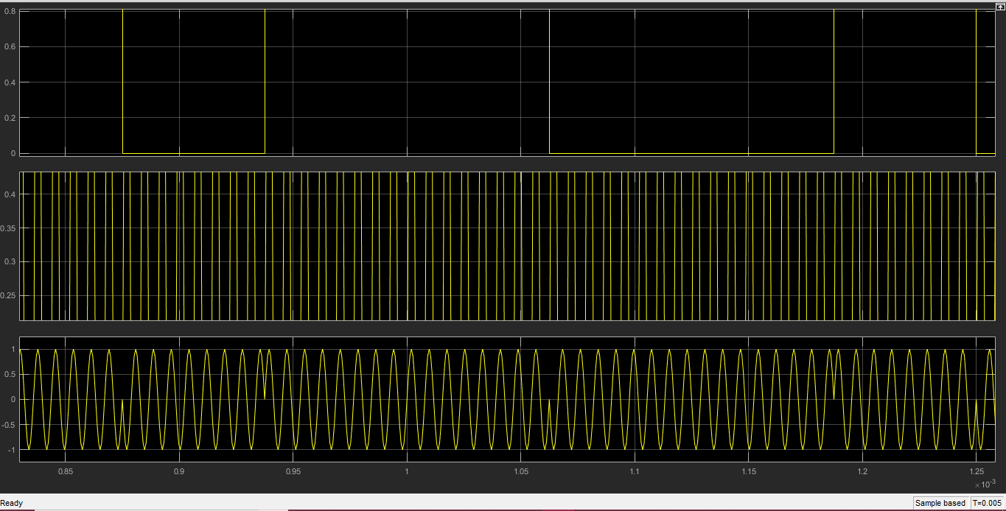

256 K Hz

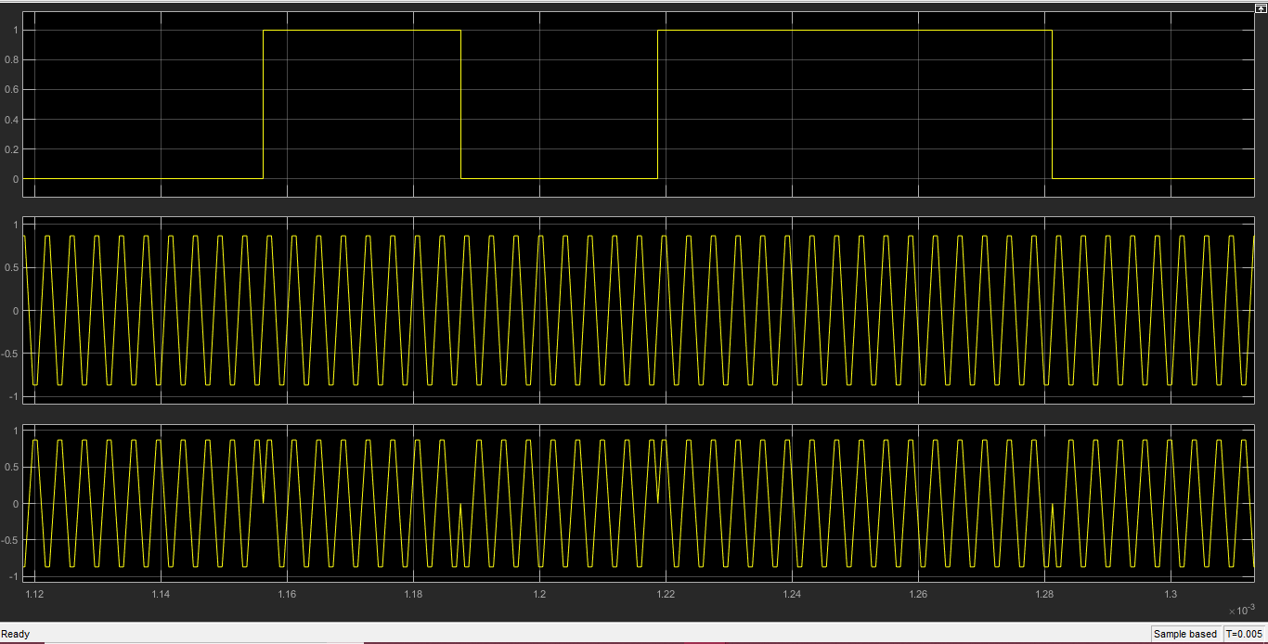

The schematic of the final BPSK modulator after modeling the different parameters like

1. Bit rate
2. Data format
3. Sub carrier frequency
4. Voltage levels

Is as follows:

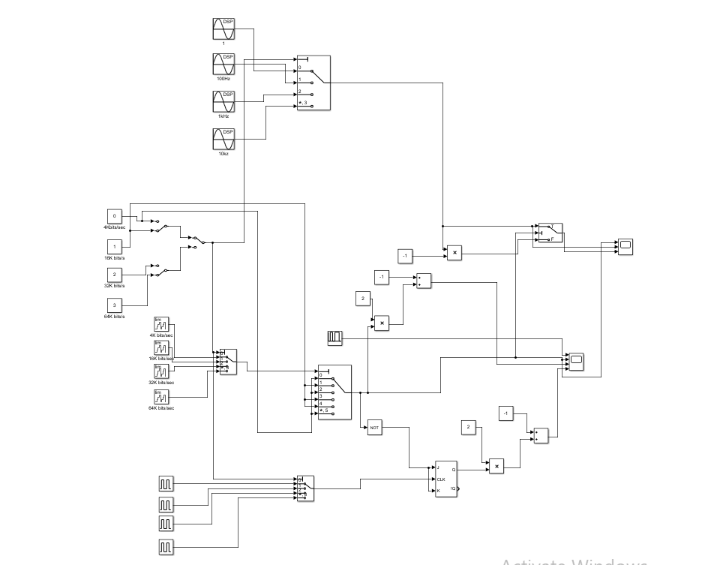

APPLICATIONS OF BPSK:-

BPSK offer several distinct properties different from other modulation techniques due to which it can be used in data transmission with lower data rates that is BPSK found its most implies applications in low speed communication systems.

CONCLUSIONS:-

Every modulation techniques has some pros and cons, BPSK modulation has also some pros and cons. Although this modulation technique is not possible to determine whether the received signal is equal to b(t) or –b(t) but it has a good power efficiency and has a simple system. It can also be used in low speed communication. On over all basis it can be said that BPSK modulation technique that can be used efficiently with lower data rate system

ACKNOWLEDGEMENT

We have put in efforts in this project. However, it would not have been possible without the kind support and help of Prof Manikandan J . We would like to extend our sincere thanks to him.

We are highly indebted to Prof Manikandan J for his guidance and constant supervision as well as for providing necessary information regarding the project & also for their support in completing the project.